Summary Sheet
Domestic Family Abuse
& Violence (DFAV) Action Plan

Once the Action Plan template has been imported into your software (see separate summary sheet) then follow these instructions to generate and send the Action Plan:

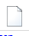
- From within Bp Premier click on the letter icon
- Select the Templates dropdown menu then Use Template > Custom
- Select your ‘DFAV GP Action Plan’ from your custom template list > Open

You will be prompted to complete custom field questions:

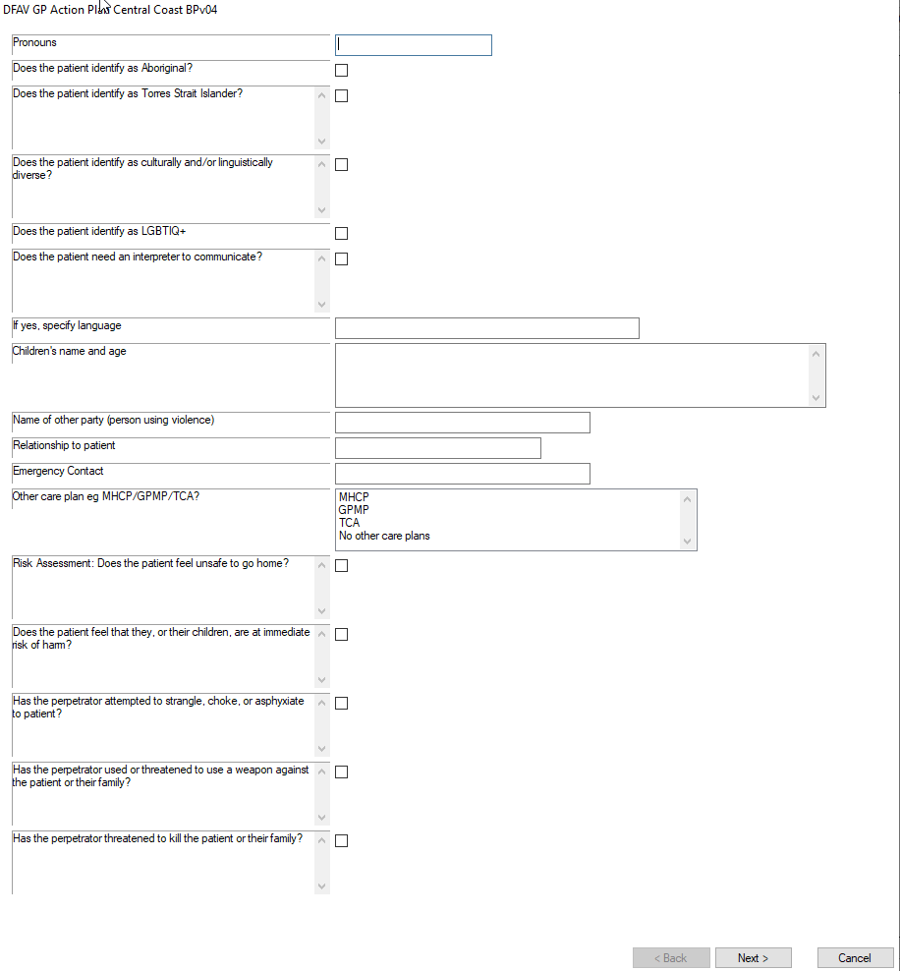

- Complete all the questions and then click Next to move to next page.
- When finished select ‘Insert’.
- Add any remaining information to the action plan if required and then send via Secure Messaging (see summary sheet).

