# **CVD Dashboard Report: Quality Improvement Activities**

**Idea One: Use of Absolute Cardiovascular Risk Score (Screening)**

How to access the Cardiovascular Risk tool in Best Practice

How to access the Cardiovascular Risk tool in Medical Director

**RISK CALCULATION**

The Framingham Risk Equation is used to calculate cardiovascular risk. This is further explained on the PenCS website under [CV Event Risk CAT Calculated](https://help.pencs.com.au/display/CG/CV+%28Cardiovascular%29+Event+Risk+CAT+calculated).

**CLINICAL GUIDELINES**

The Absolute CVD risk clinical guidelines are endorsed by the RACGP and can be found on the National Heart Foundation website. They are known as the [Absolute CVD Risk Clinical Guidelines.](https://www.heartfoundation.org.au/conditions/fp-absolute-cvd-risk-clinical-guidelines)

**PEN CAT RECIPES**

You can create lists of patients at risk of cardiovascular disease. Step-by-step guides can be found on the PenCS website under [QIM 8- Cardiovascular Risk](https://help.pencs.com.au/pages/viewpage.action?pageId=47317156).

**Idea Two: Indicated Diagnoses (Under data cleansing in software)**

Above is a screen capture showing how patients with a specific diagnosis can be identified in CAT 4. Below are values are used in the CVD dashboard report, as risk factors for CVD.

**TOPBAR**

You can also find diagnoses tools in Topbar. More information on this can be found on the PenCS website under [Indications Tab](https://help.pencs.com.au/display/TUG/Indications+Tab).

**TIDYING UP THE DATA**

More information on ‘data cleansing’ related to indicated diagnoses can be found on the PenCS website under [Data Cleansing](https://help.pencs.com.au/display/CG/Data+Cleansing).

**PEN CAT RECIPES**

Further information for diagnosis recipes can be found on the PenCS website under [Cleansing View](https://help.pencs.com.au/display/CG/Cleansing+View).

**Idea Three: Modifiable Risk Factors (Clinical Coding)**

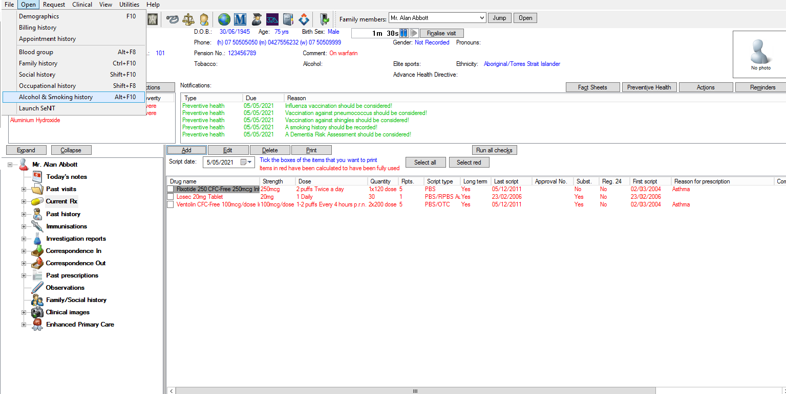

How to enter in alcohol status and smoking status into Best Practice

**STEP ONE**

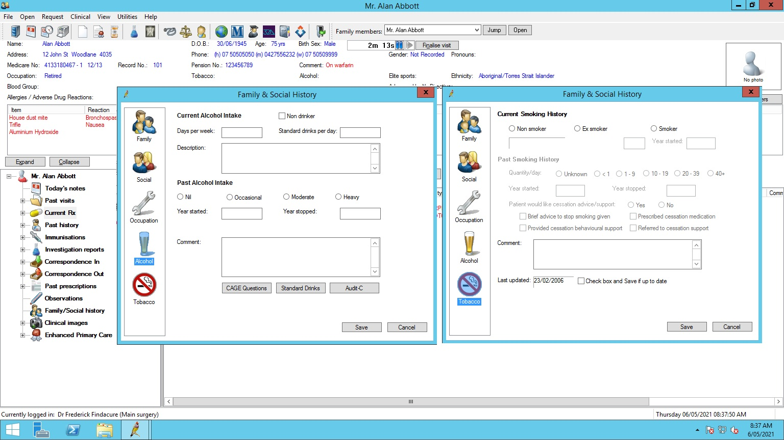

**STEP TWO**

How to enter in physical activity into Best Practice

How to enter in BMI (Height and Weight) Waist, and Blood Pressure into Medical Director.

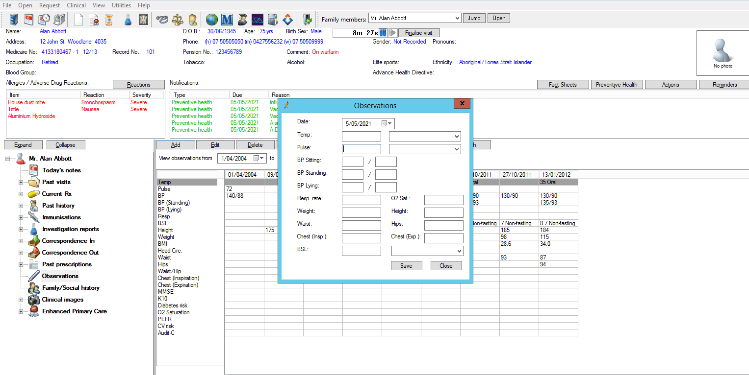

How to enter in alcohol status into Medical Director.

How to enter in BMI (Height and Weight) Waist, and Blood Pressure into Medical Director.

How to enter in physical activity into Medical Director.

How to enter in smoking status into Medical Director.

**Idea Four: Reducing CVD Risk- Looking at treatment efficacy.**

Select your active patients to filter by

**STEP ONE**

You can filter by certain medications for certain conditions i.e., medications taken to control Blood Pressure

**STEP TWO**

You can filter by certain measures such as BP targets. You can individually select or multiple sections of the graph depending on your targets

Once you have your filters, if you click ‘report’ it will give you a list of patients that show multiple lists, i.e., a patient who is taking a certain medication AND has a BP of over 140/90

**STEP FOUR**

**STEP THREE**