**CODING SMOKING STATUS INTO THE CLINICAL SOFTWARE**

How to enter in smoking status into Best Practice

**STEP ONE**

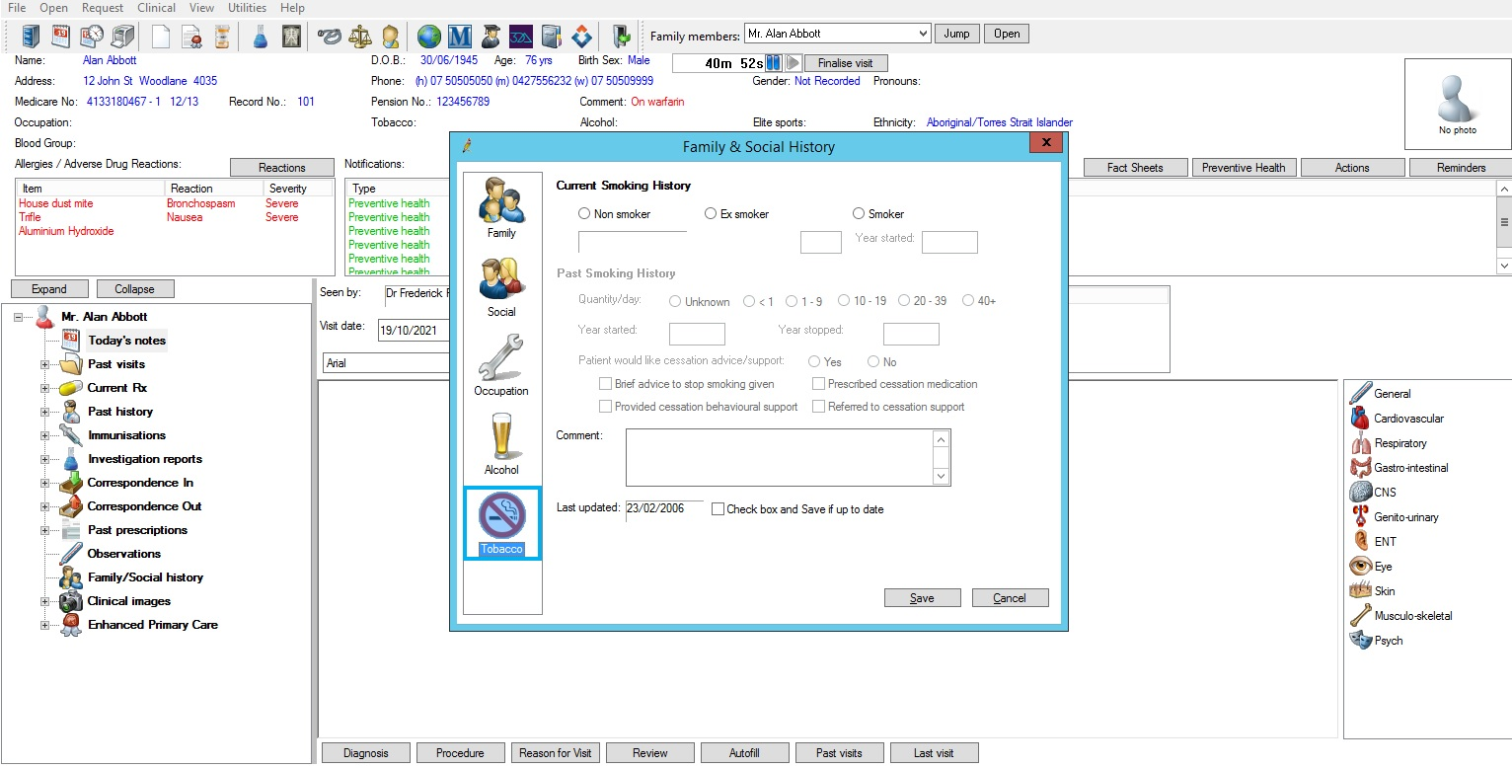

**STEP TWO**

How to enter in smoking status into Medical Director.

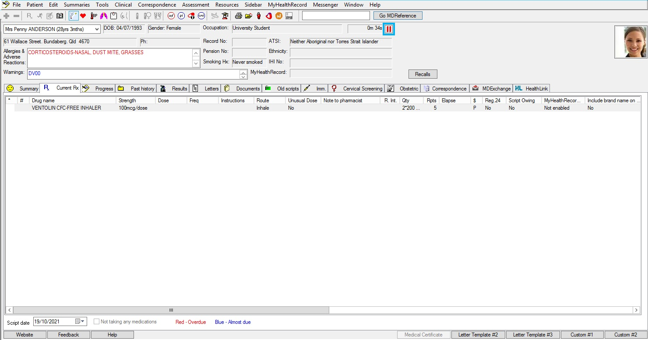

**STEP ONE**

**STEP TWO**