Summary Sheet
Importing the Domestic Family Abuse
& Violence (DFAV) Action Plan

Follow these instructions when importing the DFAV template.

If downloading from the internet:
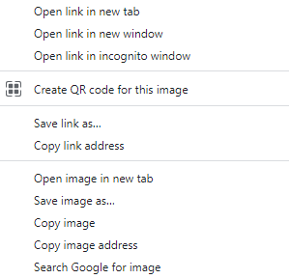
1. Right Click on the template from the web page and select ‘Save link as’ or ‘Save target as’.

Note: The template must be in rich text format or word format – not pdf.

2. Name the file and Save this file to a drive / folder on your computer/desktop.
File Type = Rich Text Format.

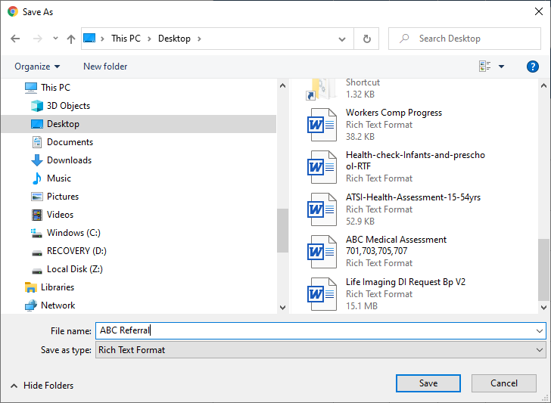
Important: Do not then double-click on this file from your computer as this will open it in Word and corrupt the fields.

3. Open BP Premier and open the Word Processor - F4 or 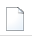blank page icon.

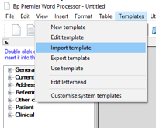

4. Select Templates > Import Template and navigate to where you saved the imported template eg. desktop.

5. Modify the template (if necessary).

6. Select File > Save As and name your template, ticking ‘Available to all users’ if you would like to share with others within the practice.

7. Save
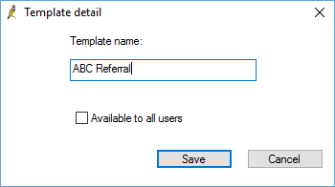

8. Your template will then be accessible in the Template > Use Template function (Custom) list.
