Summary Sheet
Domestic Family Abuse
& Violence (DFAV) Action Plan

Once the Action Plan template has been imported into your software (see separate summary sheet) then follow these instructions to generate and send the Action Plan:

- From within MedicalDirector Clinical click on the pen & paper icon
- Select your ‘DFAV GP Action Plan’ from your ‘User Defined’ template list > OK

You will be prompted to complete custom field questions:

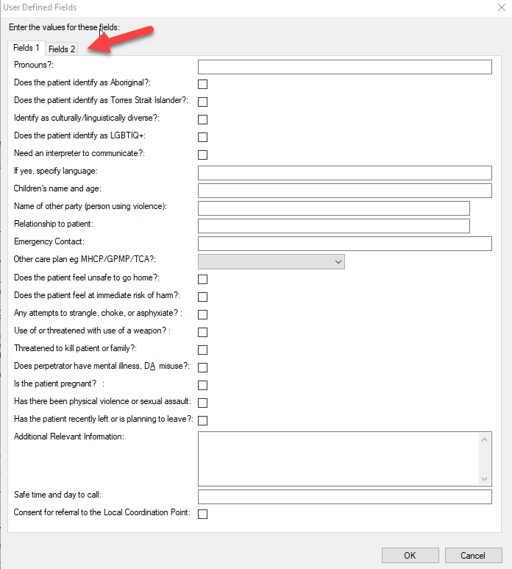

- Complete all the questions and then click the Fields 2 tab to move to the next page.
- When finished select ‘OK’.
- Add any remaining information to the action plan if required and then send via Secure Messaging (see summary sheet).

