Quality Improvement Scenario 4: Diabetes Cycle of Care completion

Evidence-based care guidelines state that a Diabetes Cycle of Care should be completed every year. Management-of-type-2-diabetes-A-handbook-for-general-practice.aspx (racgp.org.au)
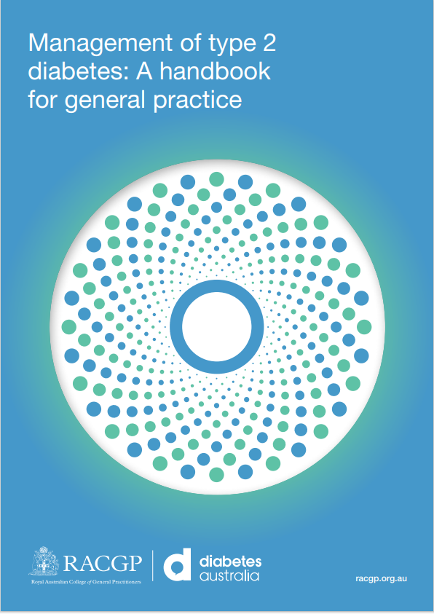

Your practice’s PenCS CAT4 tool can determine the number of patients who require an annual diabetes cycle of care. Identify patients eligible for an Annual Diabetes Cycle of Care - CAT Recipes - PenCS Help

The Practice Nurse and Quality Improvement Team wish to improve the completion of Diabetes Cycle of Care for each patient. The team pick this topic for improvement and create a Model for Improvement for the PIP QI Quarter beginning 1 May.

The SMART goal is 100% of patients with diabetes in the practice will have commenced an annual cycle of care by 31 July.

Data Baseline:

Numerator: Number of patients without a completed Diabetes Cycle of Care
Denominator: Number of Patients diagnosed with Diabetes Type 2
Example: 300/600 = 50%

Review Date: 31 July

PLAN:
Idea 1: Use Clinical Information System tools to commence and complete a patient’s Diabetes Cycle of Care.
TIP:
BP: Diabetes Cycle of Care Tool in Enhanced Primary Care < Current < Diabetes Cycle of Care Diabetes Cycle of Care (bpsoftware.net).

MD: Patient Clinical window < Clinical < Diabetes Record < Assessment. MD Online Help (medicaldirector.com)

Idea 2: Use TopBar to opportunistically identify outstanding activities of Diabetes Cycle of Care when patient is present. Diabetes Cycle of Care Eligibility - USER GUIDES TOPBAR - PenCS Help. (Please note MBS Item Numbers for Diabetes Cycle of Care and Incentive Payments have ceased.)

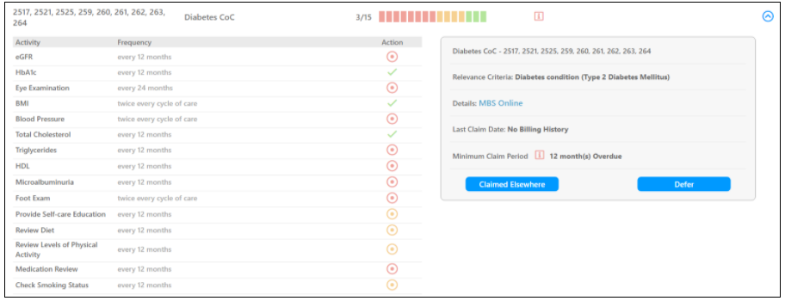

Idea 3: Set up Nurse-led clinics. Consider Role, Individual and Context Scope of practice; setting; logistics, appointment book, equipment, documentation. Explaining the essential elements of a nurse clinic (apna.asn.au)
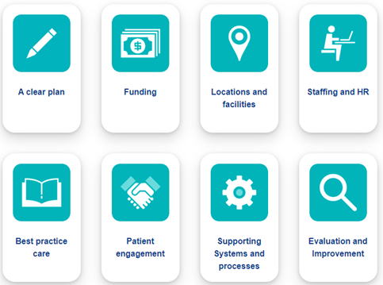

Idea 4: Attend HNECCPHN or other Nurse Education Events to upskill in Chronic Disease Management. Education Events - Primary Health Network - Page 2 (thephn.com.au)

Idea 5: Run a report in CAT4 Diabetes Cycle of Care Items completed per patient and concentrate on patients with the most items completed, e.g., patients with 10-15 already completed. Cycle of Care by Items Completed Per Patient - CAT GUIDES - PenCS Help
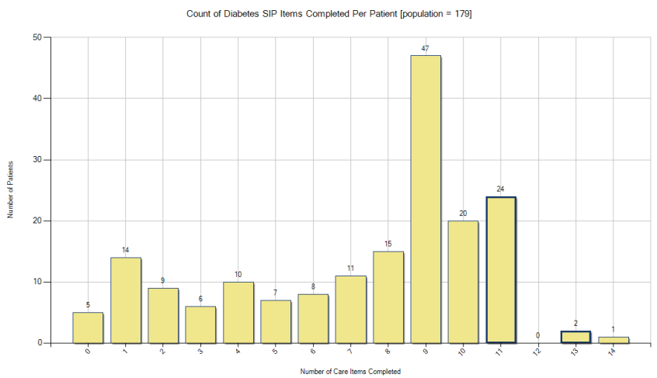
Idea 6: Run a CAT4 report of items recorded to determine the practice’s strengths and weaknesses. Diabetes Items - CAT GUIDES - PenCS Help
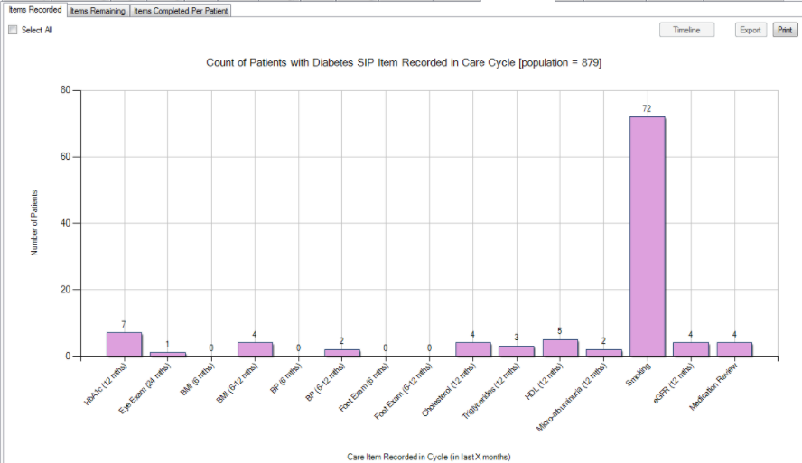

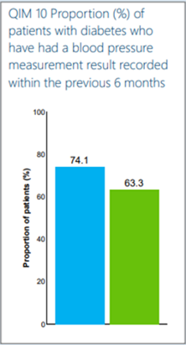
Idea 7: Use your Practice’s PHN CAT4 Dashboard to benchmark performance against other practices for Quality Improvement Measure QIM 01(HbA1c/12months), QIM 10 (BP/6 months), and Influenza immunization QIM 5.
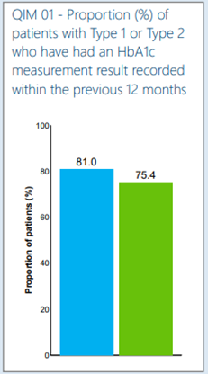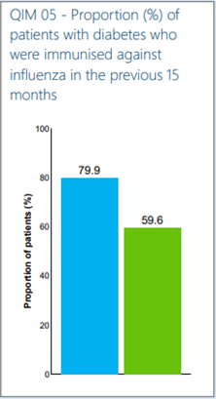

Idea 8: Make sure your activities are coded correctly. Diabetes Data Category Mappings BP - Data Mapping - PenCS Help Pathology Data Mappings All Systems - Data Mapping - PenCS Help Diabetes Data Category Mappings MD3 - Data Mapping - PenCS Help
TIP: Contact your supplier to ensure Pathology Results are sent to practice in HL7 format.

Idea 9: Use the Clinical Information System efficiently. Diabetes Cycle of Care (bpsoftware.net) MD Online Help (medicaldirector.com)

TIP: BP: Physical Activity Prescriptions must be printed for this assessment to save, but does not populate Cycle of Care.

TIP: BP: Use Observations fields to record height, weight so that Cycle of Care will automatically calculate BMI.

TIP: BP: Assess smoking status in Alcohol and Smoking History < Tobacco.
MD: Assess smoking status in Patient Details < Smoking Tab.

TIP: BP: Record a Medication Review in Enhanced Primary Care folder to code it for Cycle of Care.

_________________________________________________________________________________
By end of July quarter, the Quality Improvement Team complete the Improvement Cycle:

DO: What did you do? _____________________________________________________________________________________
STUDY: What were the reviewed results? _____________________________________________________________________________________
ACT: What can be added, continued, and/or removed from process? _____________________________________________________________________________________

