**PEN CS RECIPES FOR RISK FACTORS: SMOKING/ALCOHOL/ALLERGIES**

Step 1: Select your desired patient demographics and your active patients

**STEP ONE**

Option 1: Select a group of patients with the identified risk factor of smoking or alcohol use (and export)

**OPTION ONE**

Option 2: Select the smoking filter to identify the smoking status of your patients noted in the blue box

**OPTION TWO**

**OPTION THREE**

Option 3: Select the cessation filter under smoking to identify the readiness of the patients to cease smoking

Option 4: Select the smoking filter to identify the alcohol status of your patients noted in the blue box

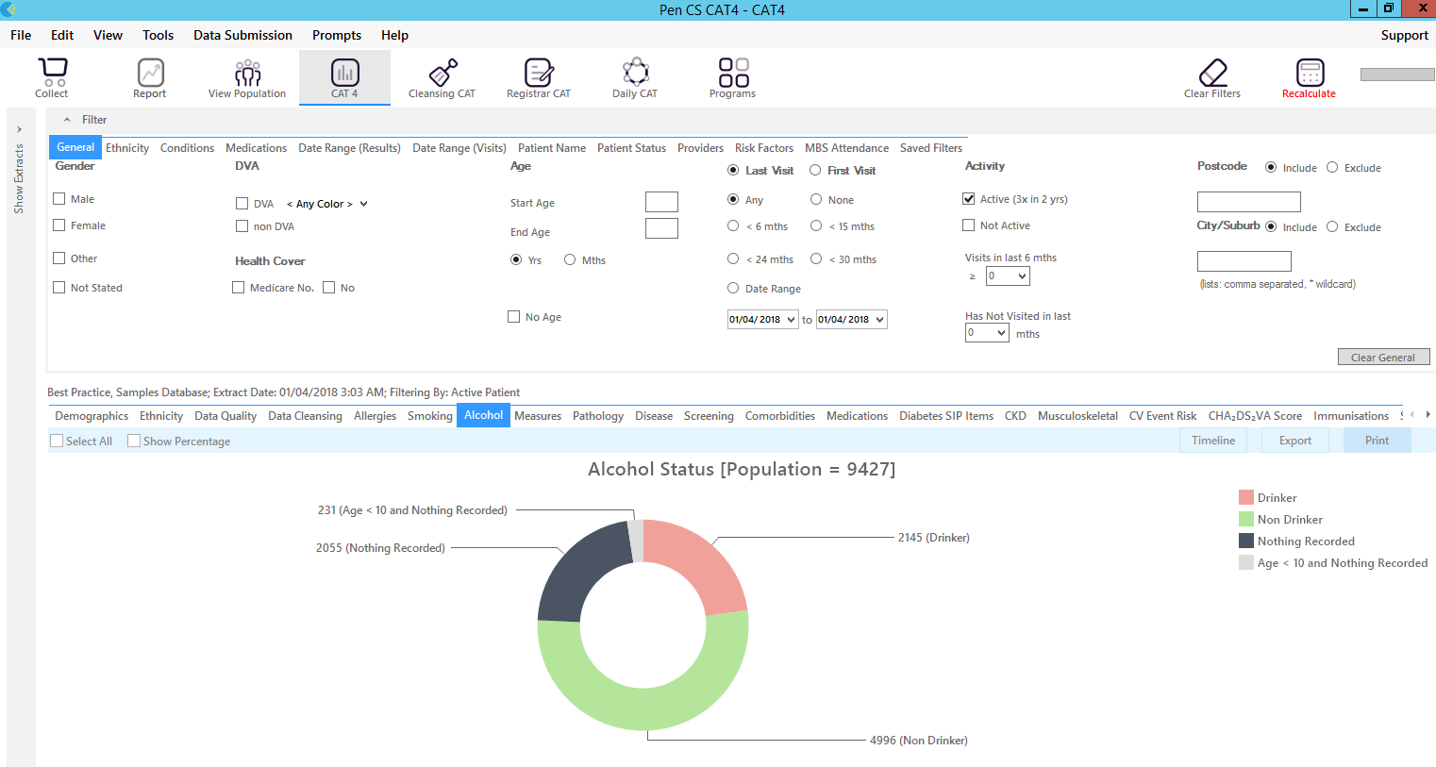

**OPTION FOUR**

Option 5: Select the allergies filter to identify the allergy status of your patients noted in the blue box

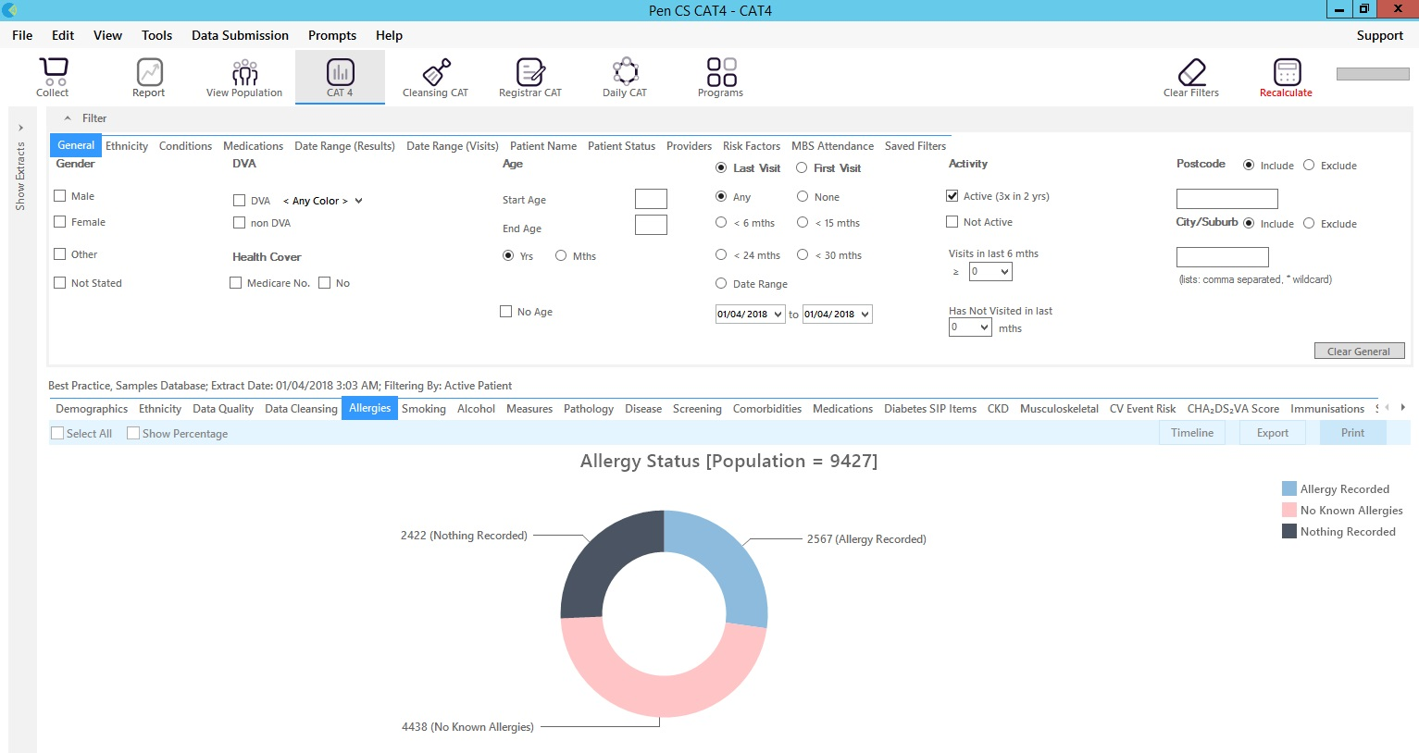

**OPTION FIVE**

Option 6: In Cleansing CAT select the Missing Clinical/Accreditation Items to identify patients with a status not recorded for risk factors such as smoking, alcohol, allergies etc.

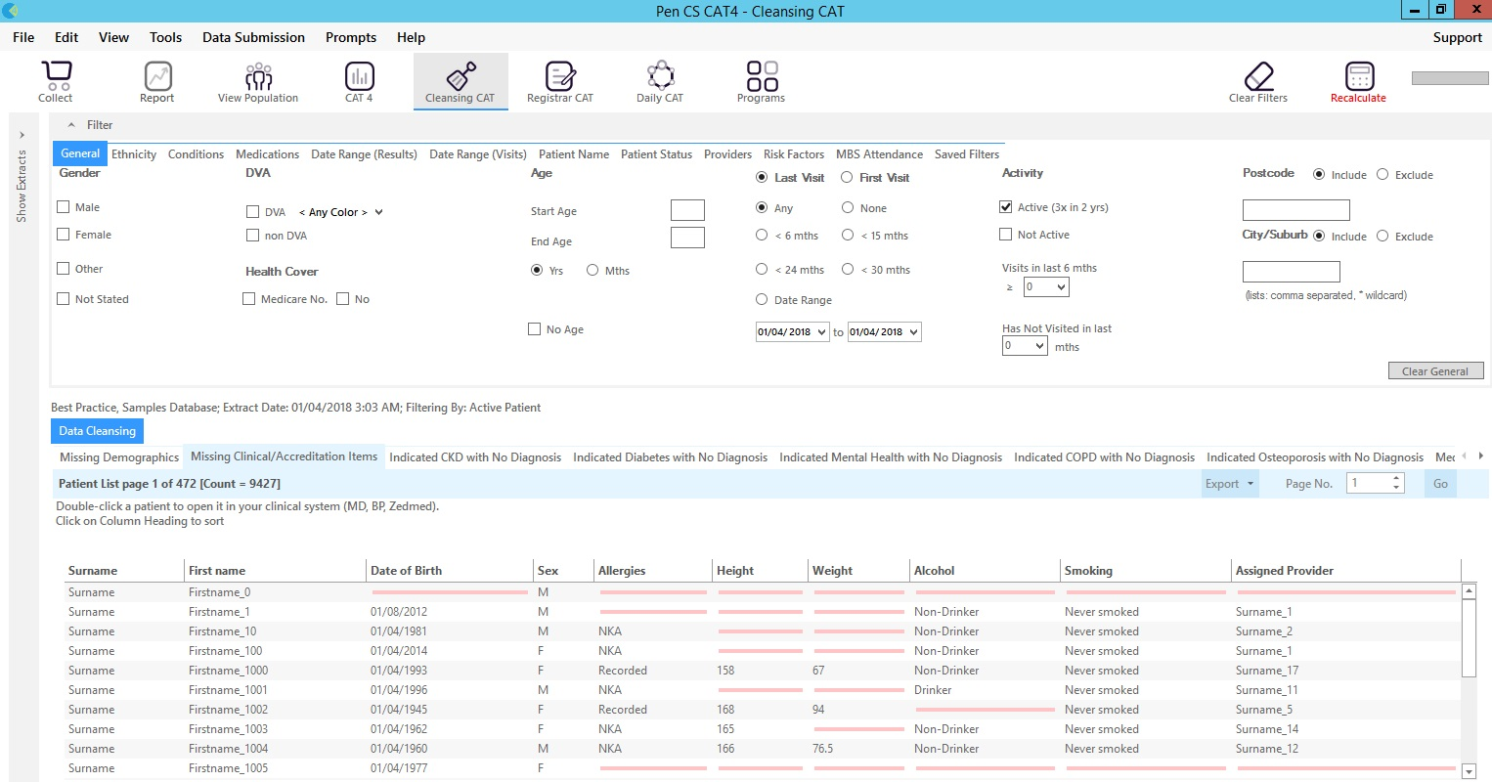

**OPTION SIX**

**FURTHER INFORMATION/RESOURCES**

For further information regarding PEN CS recipes, you can also access their website with further support

* General Support: (link to be inserted)
* Smoking: (link to be inserted)
* Alcohol: (link to be inserted)
* Allergies: (link to be inserted)

If you are looking at using these as Quality Improvement activities, you can also find a suite of resources on the PHN website in ‘Programs’- under ‘Primary Care Support’. [Welcome to the Primary Health Network - Primary Health Network (thephn.com.au)](https://thephn.com.au/)

**\*\*\* Please note, that when using the above suggest PEN CS recipes, it requires appropriate clinical coding into your clinical software (e.g., Best Practice or Medical Director) to provide accurate results.**

**If you require further support around clinical coding, you can contact your local PCIO for support and access to other resources on how to code modifiable risk factors into the system.**